**Name: Bekyrys Issayev**

**ID: 18BD1190339**

**Lab 4: System Calls**

**Lab Goals**

* To get acquainted with the low-level interface to system calls.
* To understand how programs can work without the standard library.
* Basics of directory listings, through a first attempt at executable file viruses.
* Debugging programs via printouts (the idea of debug mode, continued).

**Task 0a: a trivial program using only system calls**

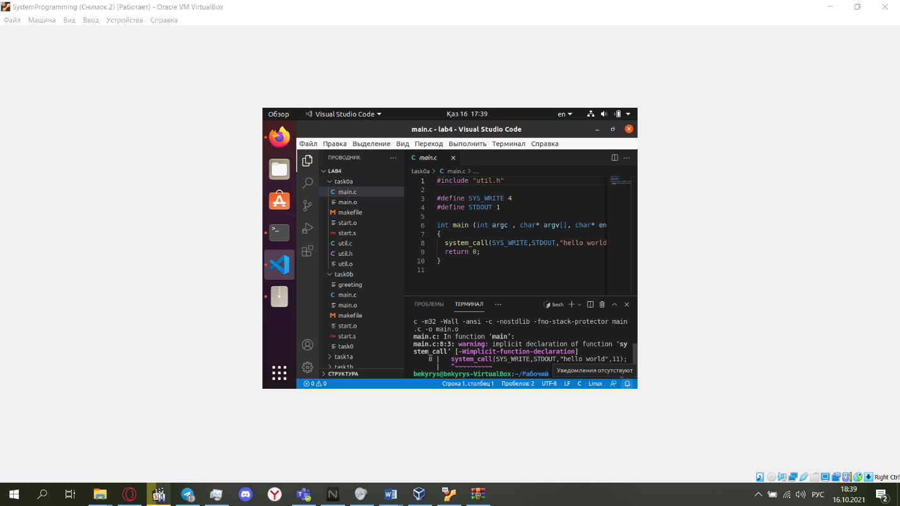

Note that when compiling "main.c" a warning about "implicitly defined system_call" probably appears. How should this be fixed?

**Answer:** Use static inline instead of plain inline. Plain inline supplies an inline definition, but the compiler is free to ignore it and use the external definition instead.

**Task 0b: Patching executable files**

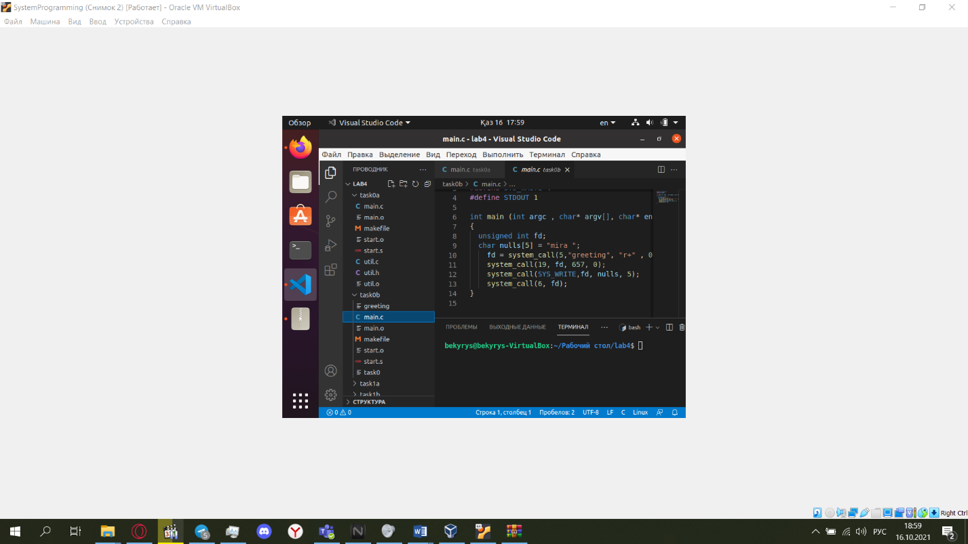

**Task 1a: A restricted encoder version**

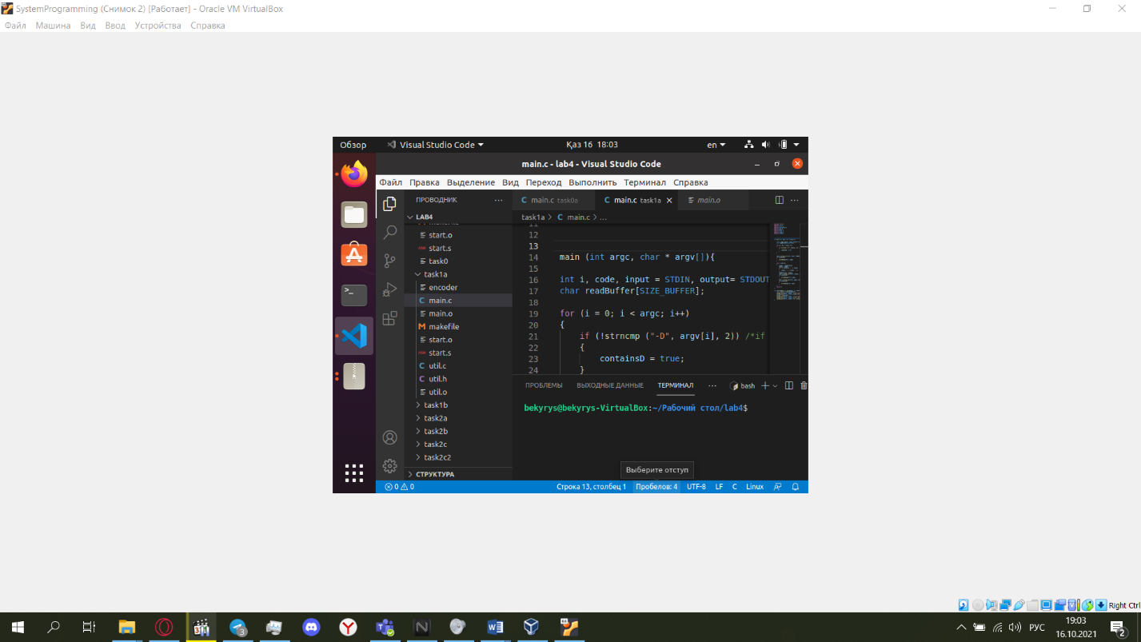

**Task 1b: Working with files**

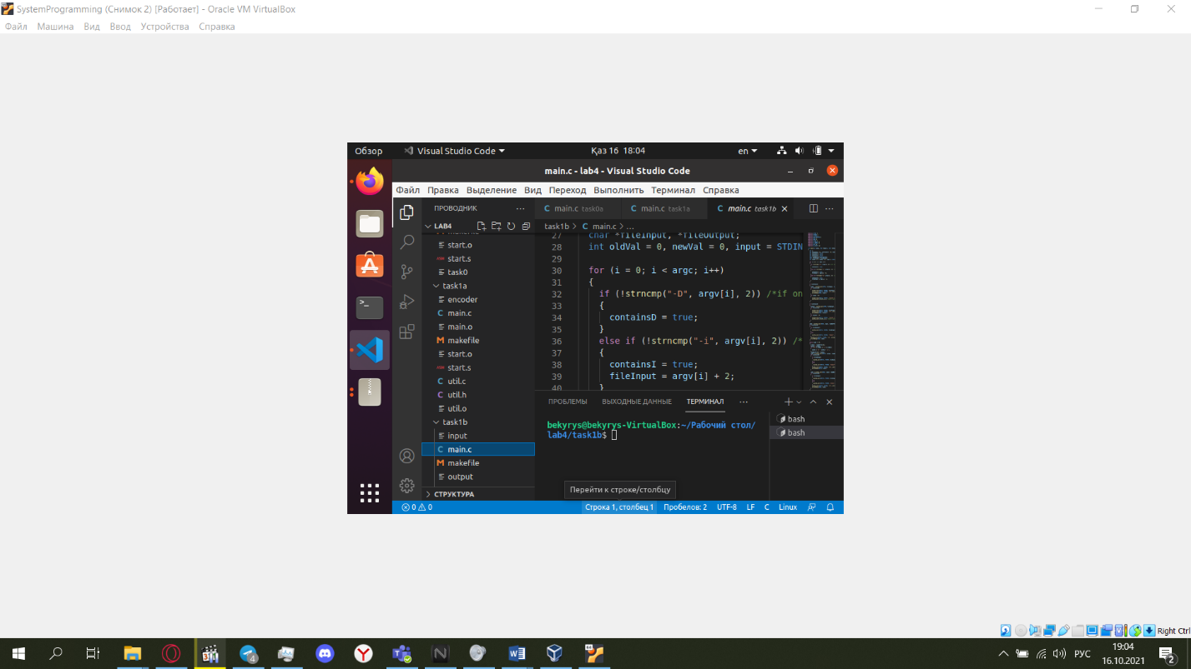

**Task 2a: A restricted flame2 version: printing a list of all files**

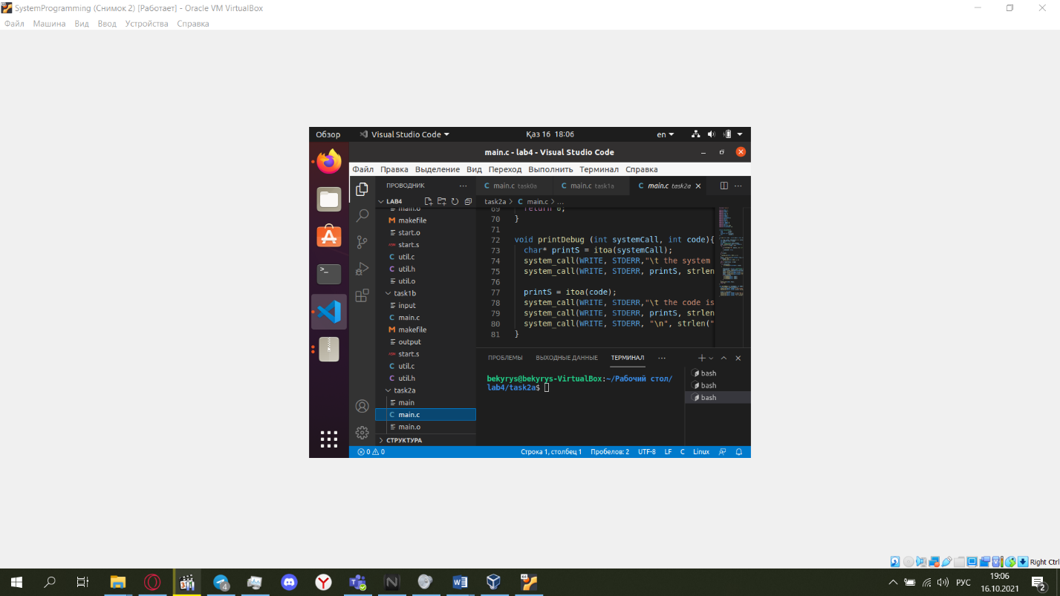

**Task 2b: Extending flame2: printing a list of all files with a given prefix**

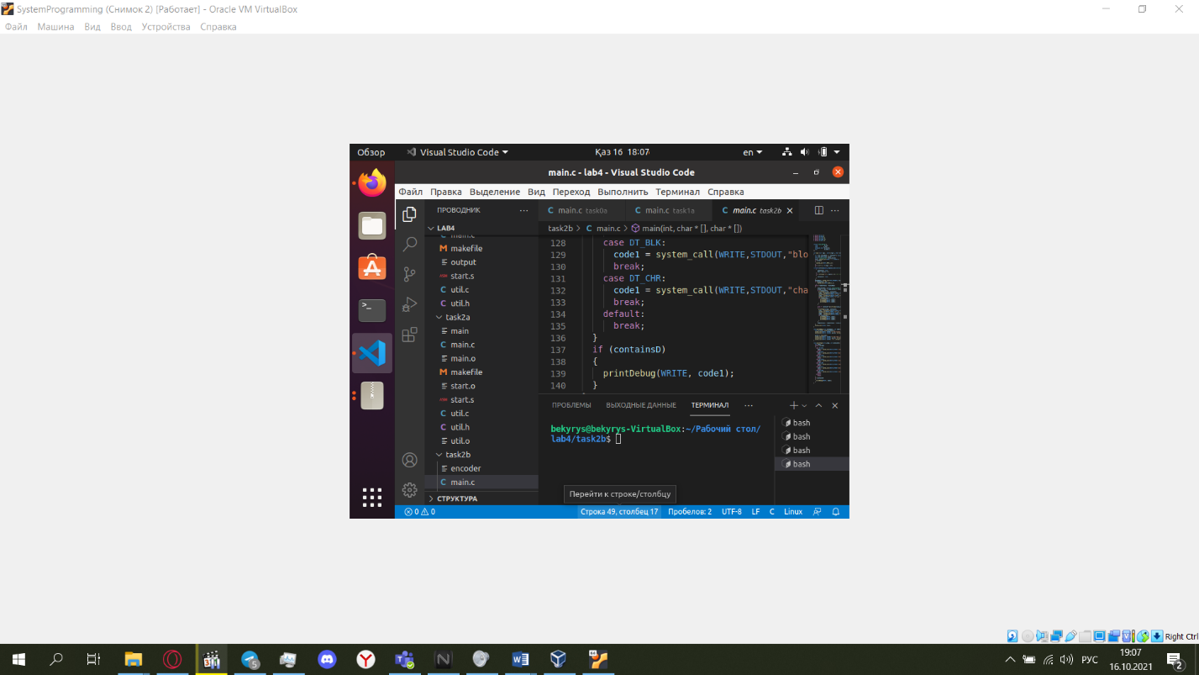

**Task 2c: Extending flame2: Add the executable code of flame2 to each file obtained from Task2b**

